C:\Users\Admin\ffmpeg-master-latest-win64-gpl-shared\ffmpeg-master-latest-win64-gpl-shared\bin

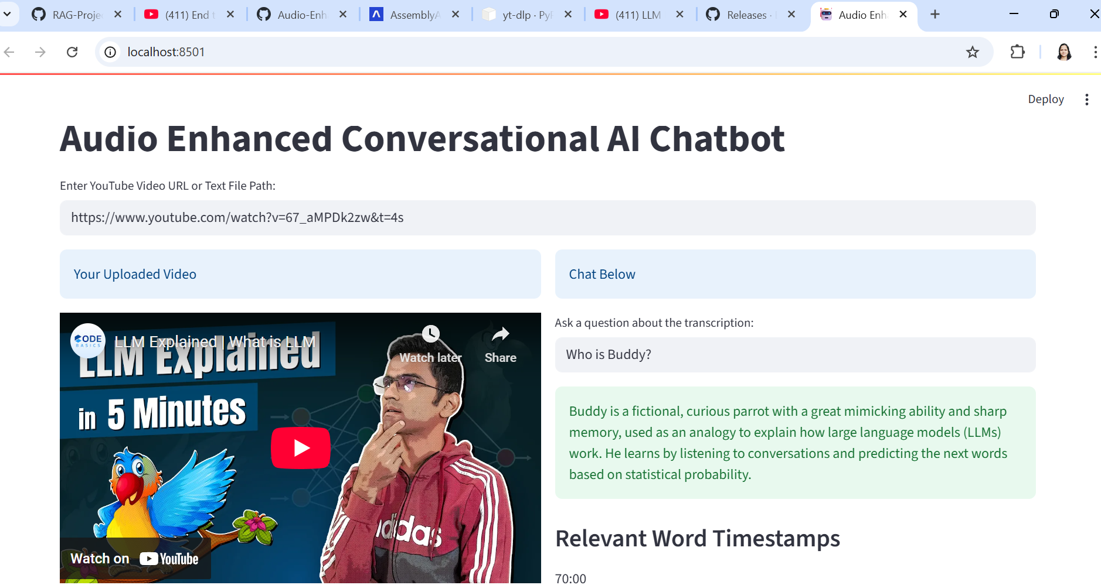

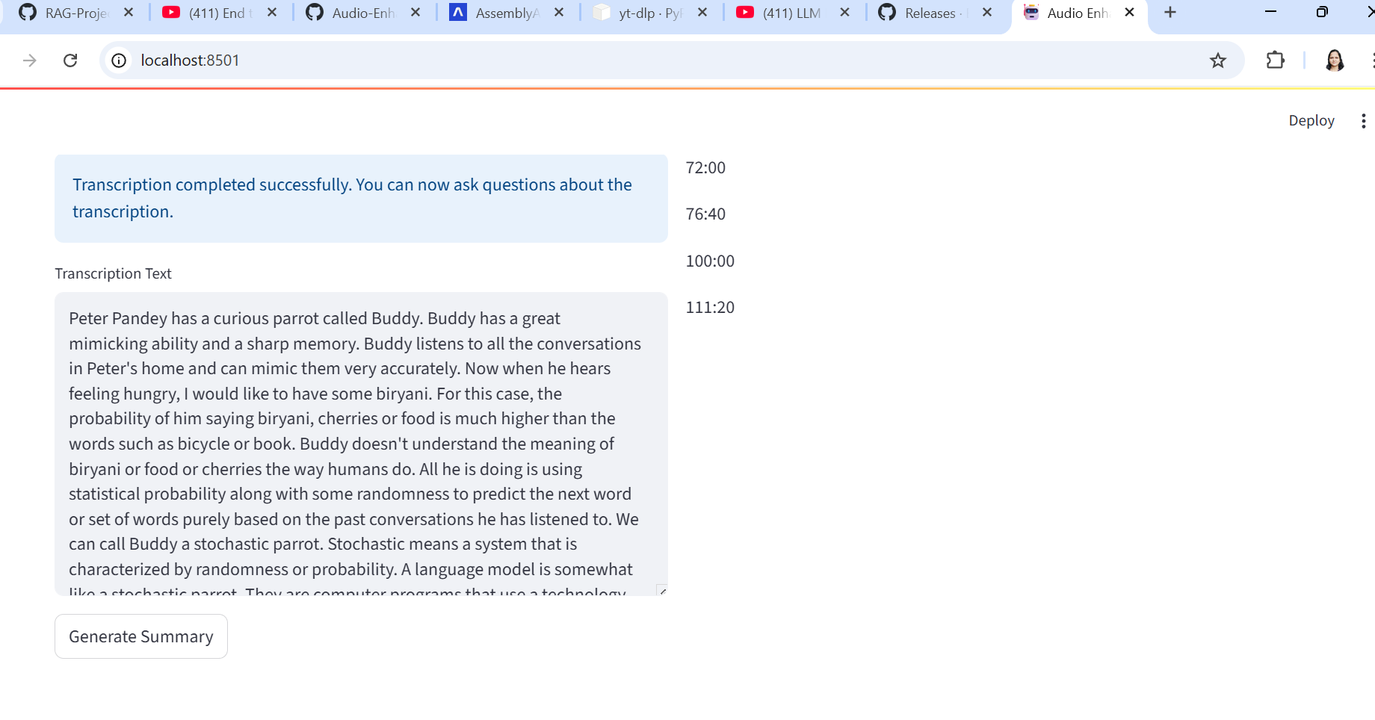

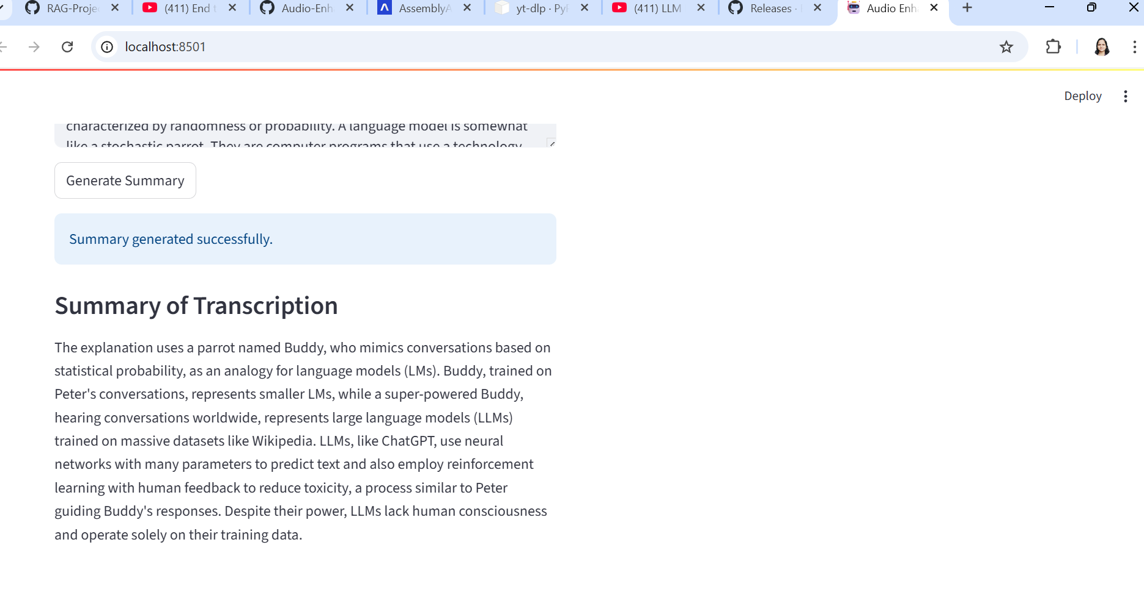

Here are some tailored and creative project title suggestions that align beautifully with the scope and functionality of your tool:

🎯 Practical & Professional Titles

* **VidQuest AI**: Semantic Retrieval and Chatbot System for YouTube Videos
* **YTInsight**: Transcript Summarization and RAG-powered Conversational Agent
* **YouSummarize**: End-to-End Video Understanding with Gemini-powered Retrieval
* **TranscriptoRAG**: Video Transcript Summarization and RAG-based Chatbot using Gemini

💡 Creative & Catchy Titles

* **TubeSage**: Your Smart Companion for Summarizing and Conversing over YouTube Content
* **EchoBot**: Listen, Learn, and Talk with YouTube—Powered by Gemini
* **ClipQuery**: Conversational Intelligence over Video Content with Timestamped Retrieval
* **DeepDiveTube**: From Transcription to Query—Your Personal AI for Video Exploration

🔍 Academic or Research-Oriented Titles

* **Multi-Modal Semantic Understanding of YouTube Videos Using Gemini LLM and RAG Retrieval**
* **End-to-End Conversational RAG Framework for Video Transcripts with Timestamp-based Evidence Extraction**

If you’re showcasing this as part of your portfolio or certification, you might want to emphasize either the technical depth (e.g. Gemini, RAG, chatbot NLP) or user-centric aspects (e.g. summary generation, timestamped content delivery). Want me to help tailor one for your resume or GitHub?